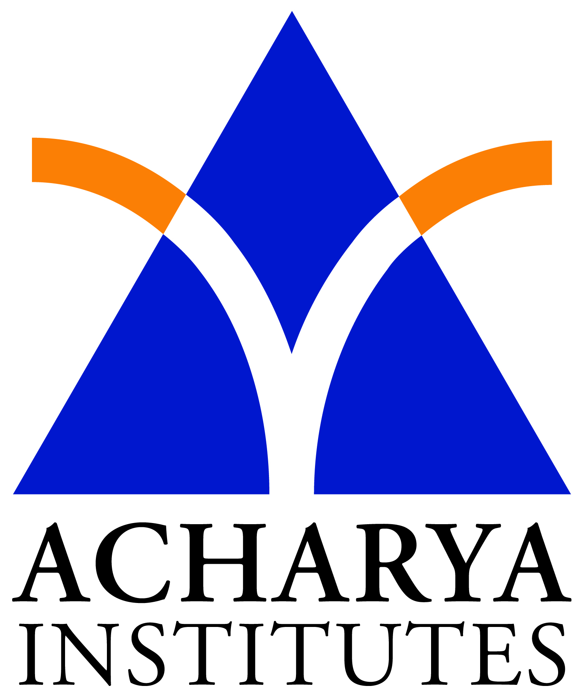 Smt. Nagarathnamma College of Nursing
Soladevanahalli, Bangalore – 90

HEALTH PROMOTION
Introduction:

Health has been by the world health organization as a state of complete mental, physical, and social well-being and not merely an absence of disease or infirmity. And it is health rather than illness that is finally becoming the focus of our health services. One that stresses health promotion and the prevention of illness as matter of primary concern, with restoration to optimum health, not merely the curing of disease, as the goal of therapeutic care. Even the language we use in connection with health care is changing to reflect a more optimistic outlook. Instead of discussing “treatment” levels, people are now talking about levels of health promotion or level of disease prevention to describe health services. The three levels of health promotion most commonly discussed are:

- primary health promotion

- secondary health promotion

- tertiary health promotion
Primary health promotion:

This is concerned with encouraging people to become as fit and healthy as possible so that they are able to enjoy life to the fullest. Primary promotion encompasses generalized health promotion as well as specific protection against diseases. Services such as nutrition, counseling on exercise and hygiene, and immunization against specific diseases would be included in primary promotion programs.
Secondary health promotion:

This is concerned with both (a) the early detection of deviations from normal growth and development, or signs of ill health, and (b) prompt intervention either to prevent abnormality or illness or to lessen their severity. Secondary promotion services include screening programs such as the mass screening of specific population groups to detect persons with tuberculosis or the hypertension screening clinics that are often held in shopping malls by the Heart Association and other groups. Also included at the secondary level is the care and treatment of ill an outpatient basis in a clinic or in the home.

Tertiary health promotion:

This level is primarily oriented toward rehabilitation, with services designed to restore individuals who have been ill or disable to as full and independent a life as possible within the constraints of their disability. Services at this level include the retraining of individuals in basic life skills- if necessary, to walk or perhaps to talk again, to adjust to their disability, and, sometime to reorient their life to accommodate the residual effects of an illness or to prevent its recurrence.

Although the level of health promotion have been described separately, it is important to remember that they exist on a continuum, with many of the services overlapping in actual practice.

Health promotion is the process of enabling people to increase control over, and to improve health. It is not detected against any particular disease, but is intended to strengthen the host through a variety of approaches (intervention). The well-known interventions in this area are:

- Health education
- Environmental modifications
- Nutritional interventions
- Disability limitation
- Rehabilitation

Health education:

This is one of the most cost effective interventions. A large number of diseases could be prevented with little or no medical intervention if people were adequately informed about them and if they were encourage to take necessary precaution in time. Recognizing these truth, the WHO’s constitution states that “the extension to all the people of the benefits of medical, psychological and related knowledge is essential to the fullest attainment of health”. The targets for educational efforts may include the general public, patients, priority groups, health providers, community leaders and decision-makers.

Environmental modification:

A comprehensive approach to health promotion require environmental modification such as provision of safe water, instillation of sanitary latrines, control of insects and rodents, improvement of housing, etc. The history of medicine shown that many infectious disease have been successfully controlled in western countries through environmental modifications, even prior to the development of specific vaccines or chemotherapeutic drugs. Environmental intervention are non-clinical and do not involved the physician.

Nutritional intervention:
These comprise food distribution and nutrition improvement of vulnerable groups; child feeding programs; food fortification; nutrition education, etc.

Lifestyle and behavioral changes:

The conventional public health measures of intervention have not been successful in making inroad into lifestyle reforms. The action of prevention in this case, is one of individual and community responsibility for health, the physician and in fact each health worker acting as an educator than a therapist. Health education is a basic element of all health activity. It is of paramount importance in changing the view, behavior and habit of people.
Since health promotion comprises a broad spectrum of activities, a well conceived health promotion program would first attempt to identify the “target groups” or at risk individuals in a population and then direct more appropriate message to them. Goals must be defined. Means and alternative means of accomplishing them must be explored. It involves “organizational, political, social and economic interventions designed to facilitate environmental and behavioural adaptations that will improve or protect health”.

HEALTH PROMOTION TOPICS:

INFANTS:
- Infant-parent bonding
- Breast feeding
- Sleep patterns
- Playful activity to stimulate development
- Immunization
- Safety promotion and injuiry control
CHILDREN:
- Nutrition
- Dental checkups
- Rest and exercise
- Immunization
- Safety promotion and injury control
ADOLESCENTS:
- Communicating with the teen
- Hormonal changes
- Nutrition
- Exercise and rest
- Peer group influences
- Self-concept and body image
- Sexuality
- Safety promotion and accident prevention

ELDERS:
- Adequate sleep
- Appropriate used of alcohol
- Dental/oral health
- Drug management
- Exercise
- Foot health
- Health screening recommendations
- Hearing aid use
- Immunizations
- Medication instruction
- Mental health
- Nutrition
- Physical fitness
- Preventive health services
- Safety precaution
- Smoking cessation
- Weight control

SITES FOR HEALTH-PROMOTION ACTIVITIES:

Health-promotion programs are found in many settings. Programs and activities may be offered to individuals and families in the home or the community setting and at schools, hospitals, or worksites. Some individuals may feel more comfortable having a nurse, diet counselor, or fitness expert come to their home for teaching and follow-up on individual needs. This type of program, however, is not cost effective for most individuals. Many people prefer the group approach, find it more motivating, and enjoy the socializing and support. Most programs offered in the community are group oriented.

Community programs are frequently offered by cities and towns. The types of program depends on the current concerns and the expertise of the sponsoring department or group. Program offering may include health promotion, specific protection, and screening for early detection of disease. The local health department may offer a town-wide immunization program or blood pressure screening. The fire department may disseminate fire prevention information; the police may offer a bicycle safety program for children or a safety driving campaign for young adults.

Hospitals began the emphasis on health promotion and prevention by focusing on the health of their employees. School health-promotion programs may serve as a foundation for children of all ages to gain basic knowledge about personal hygiene and issues in the health sciences. Because school is the focus of a child’s life for many years. The school nurse may teach program about basic nutrition, dental care, activity and play, drug and alcohol abuse, domestic violence, child abuse, and issues related to sexuality and pregnancy.

Nurses can inform elders of available community resources such as working groups. Nurses can address the need for health protection and health promotion through teaching classes at retirement communities and other community resource centres for elders.

PRIMARY HEALTH CARE
Introduction:

In 1977, the World Health Assembly gave the call of “Health For All by 2000 AD”. Health for All basically meant that individuals should attain a level of health which would enable them to earn their livelihood and lead a socially congenial life. If this level of health is achieved, the individual and family needs would be adequately met.
Definition:

Primary health care, is defined as “a combination of primary care public health care made universally accessible to individuals and families in the community, with their full participation, and provided at a cost that the country and community can afford”
---- WHO 1978

Characteristics of primary health care:

- It is essential health care which is based on practical, scientifically sound and socially acceptable methods and technology.
- It should be rendered universally, acceptable to individuals and the families in the community through their full participation.
- Its availability should be at a cost which the community and country can afford to maintain at every stage of their development in a spirit of self reliance and self-development.
- It requires joint efforts of the health sector and other health related factors, viz, education, food and agriculture, social welfare, animal husbandry, housing, rural reconstruction etc.
Concept of primary health care:

The concept of primary health care is not new to many of the leaders in the field of health particularly to those who were involved in the development of community health programs in late 1950s.
The concept of PHC was born in India as it may be recalled during the post-Independent era in 1947, when the Bhore Committee brought its recommendations of integrating preventive health activities along with curative services in offering healthcare to people in rural and remote areas through the organization of health centers in remote areas.
Bhore Committee’s proposal is well known to us as nurses. However they are high lighted as follows.
- To provide comprehensive preventive and curative health service to the people in rural areas through the network of PHC. Health care is accessible to all.
- A-Short-term plan was formulated according to which it was proposed to establish a PHC for a population of 40,000 and to have a secondary unit to supervise 30 PHC with 650 beds. Further to have a specialty district hospital, this would serve as a referral center.
ALMA – ATA DECLARATION:
Now the concept of PHC has become once again on global level with the Alma-Ata declaration at the USSR in 1978, when the world experts met to focus their thoughts to formulate strategies to deliver healthcare to the “Have not” and to those at the grass root level.
With increasing recognition of the failure of existing health services to provide healthcare, alternative ideas and methods to provide healthcare have been considered and tried. Discussing these issues at the joint WHO-UNICEF International conference in 1978 at Alma –Ata, the Government of 134 countries and many voluntary agencies called for a revolutionary approachs to health care. Declaring that “the existing groups inequality in the health status of people particularly between developed and developing countries as well as within countries is politically, socially and economically unacceptable”. This conference called for acceptance of the WHO goal of health for All by 2000 AD and proclaimed PHC as way to achieving Health for All.
This Alma Ata Declaration has called on all governments to formulate national policies, strategies and plan of action to launch and sustain PHC as part of a national health system. It is left to each country to innovative according to its own circumstances to provide PHC. This way followed by the formulation and adoption of the global strategy for health for all by
2000 AD.

ELEMENTS OF PRIMARY HEALTH CARE:

- Health education:

Educating the people about prevalent health problems, their control and the methods of prevention
- Nutrition:

Encouraging the suitable nutrition and the food supply
- Water and sanitation;

Supply of safe drinking water and maintenance of essential sanitation facilities
- Maternal and child health:

In addition to taking care of mother and child’s health, it also includes family services.
- Immunization:

Protection from major infectious diseases

6) Prevention of endemic diseases:
Control and prevention of endemic diseases
- Treatment:

Treatment of general diseases and injuries

- Drug availability:

Ensuring easy availability of drugs

PRINCIPLES OF PRIMARY HEALTH CARE
According to WHO, there are five principles:
- Equitable distribution
- Community participation
- Appropriate technology
- Focus on prevention
- Multisectorial coordination

Equitable distribution:

The health services and resources should be equally distributed regardless of color, caste, sex, area, religion and money etc. this principles state that’s PHC should be available to all individuals, family and community without any discrimination. Thus PHC is based on the concept of social justice, availability of health care system to poor. People living in rural areas are the main target of PHC.

Community participation:

Through ultimate responsibility of health lies with the government but PHC is by the people and for the people, therefore active participation of individual, family and community is necessary. It is difficult to achieve the goals of primary health care if support of local community is not available.

Appropriate technology:

In PHC only those techniques should be used which are suitable to local requirements, socially acceptable, within the financial limits and scientifically recognized. Instead of costly equipment and big and attractive hospitals etc only locally available technologies should be used in PHC. E.g.: used of oral rehydration

Focus on prevention:

Main focus of PHC is not the treatment but prevention of diseases and it is a part of all the constituents of health services. Health education is also stressed by PHC.

Multisectorial coordination:

Only medical field cannot replace all the constituents of PHC. Therefore, proper coordination should be planned among, medical field, agriculture, housing, nutrition, public works, communication and education etc. providing PHC requires the joint efforts of all these fields.

ROLES OF NURSE IN PRIMARY HEALTH CARE:

- Primary health care is the natural extension of nursing practices, especially as it applies to community health. However in the hospital also can be integrated because nursing with primary health care concept is addressing today to the health needs of person’s throughout the whole health care process. Health care process may be in clinics, houses, schools, hospitals, where nursing care is offered.
- The primary health care concept helps the nurses to become sensitive, to provide services related to health promotion, health maintenance, primary prevention of illness, disability etc.
- PHC approach helps the nurse to assess the health of the individuals, groups and communities.
- Nurses adopting the PHC concepts are essentially generalists who are equipped to manage all age groups as well as prepared to serve everyone.
- Nurses essentially participating in PHC in the following areas:
  - Provision of direct services to patients both preventive and curative at the out-patient, in-patient clinics and community where they can give supportive services also in relation to safe-water, adequate nutrition, adequate sanitation, control of infectious diseases, immunization and promotion of mother child care including family planning.
  - The nurses can be instrumental in bridging the gap between preventive and curative services.
  - Health education in all the above areas
  - Education and training of individuals, auxiliaries and others.
  - Research and development
  - It is emphasized that the traditional healers such as Ayurvedic, Unani, and Sidha doctors are to be included in this package of PHC. The nurses need to consider this in cooperating with those personnel and involved their services while promoting health in any setting.
the nurses in India can implement primary health care effectively only by working in a team in any setting. This means a nurse is an important member of the health and development team in promoting PHC. b.i publication, page no—777,778-789.

- The nurses in developing countries especially in India have a significant role in providing primary health care in carrying out specially preventive, promotive curative and rehabilitative services.
- The nurses should see that the PHC is made available, accessible, affordable and appropriate to all. This need to be relevant to the urgent needs, and adapting to the socio-cultural factors and economic resources of the community.
- The nurses can be instrumental in promoting community and people’s participation thus assisting them to identify their health needs and providing self help in meeting such needs. This will promote self-reliance of a community.

Required skill for nurses like social process skills which include perception, communication values, empathy and accepted social behavior in order to maintain good interpersonal relationship to every member of the health team and the community. She also must have problem solving skill and other necessary skill.

